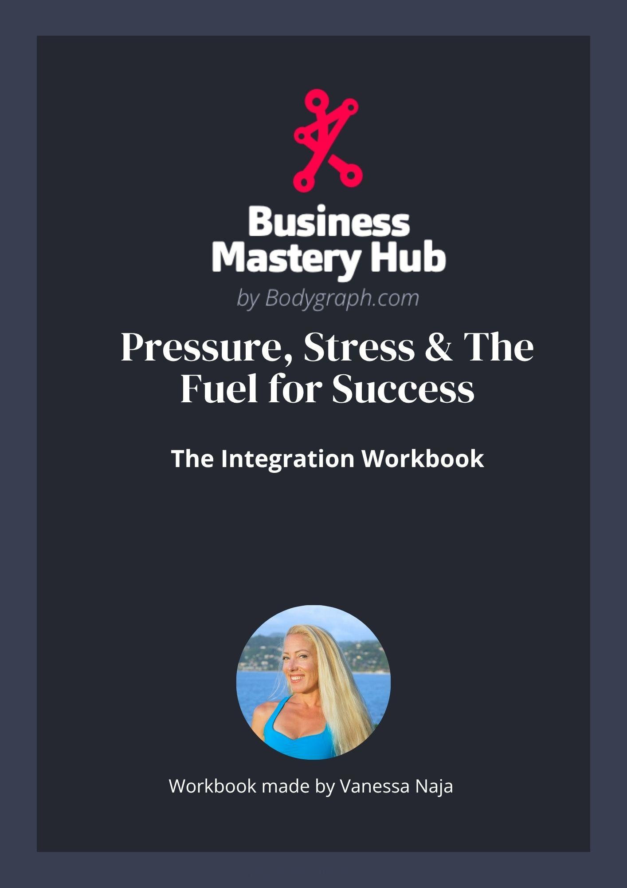

PRESSURE, STRESS & THE FUEL FOR SUCCESS
Integration & Application Worksheet
This worksheet is designed to help you apply what you just learned, not just think about it.
Move through it at your own pace. You don’t need to complete everything at once.
As you go:
- stay connected to your own experience rather than trying to get the “right” answers
- notice what actually resonates in your body
- use your authority to guide what you act on and what you leave
You can come back to this multiple times.
Each time you work with it, you’ll notice more and deepen your ability to work with pressure in a way that supports you.

1. WHERE PRESSURE IS SHOWING UP
Identify one current situation:

What does the pressure feel like?
- urgency
- restlessness
- tension
- emotional intensity
- drive to act
- other

2. CORE DISTINCTION
Pressure creates movement.
Decision-making comes from your authority.
When pressure shows up, remind yourself:
“This is pressure, I don’t decide from this!”
When I feel pressure, I will:
- notice it
- give it space
- check my authority
- move when it’s correct for me
Apply it to your situation:
What am I feeling pushed to do?

What feels true for me beyond the pressure?

3. YOUR PATTERN WITH PRESSURE
Notice what resonates:
- I move quickly/rush when I feel pressure without listening to my inner authority
- I absorb pressure from others
- I tend to internalize pressure and create pressure for myself
- I tend to externalize pressure and pressure others
- I feel overwhelmed when pressure builds
What shifts when I slow this down and become aware of it?

4. DEFINED VS UNDEFINED ROOT
(How you experience pressure)

Defined Root (consistent pressure)
Pressure is something you generate.
It can feel like a steady drive to move, complete things, or get something done.
At its best, this creates:
- momentum
- stamina
- the ability to initiate movement
At its extreme, it can feel like:
- constant internal pressure
- pushing beyond your natural timing
- placing pressure on others
Practice:
When you feel pressure, stay with it without immediately acting.
Notice:
- Does this need to move right now?
- Is this the right timing for action?
Write what you notice:

Undefined Root (inconsistent / amplified pressure)
Pressure is something you experience through your environment.
It can feel intense, immediate, and urgent, even when it is not yours to act on.
Common patterns:
- moving quickly to relieve pressure
- trying to keep up with others
- acting to release the feeling
Your strength here is awareness.
You can learn to recognize:
- what pressure belongs to you
- what pressure is coming from others
- what pressure is useful to engage with
Practice:
When you feel pressure, create a moment of space.
Notice:
- Where is this coming from?
- Do I actually need to act on this?
Write what you notice:

5. EXPANDING YOUR CAPACITY
(Working with pressure over time)

Your Capacity for Pressure
Pressure is part of growth.
As your life and business expand, so does:
- responsibility
- visibility
- decision-making
- Knowing when to move vs when to pause
Your experience of this depends on your capacity to hold it.

Notice Your Current Edge
Where does pressure start to feel like too much?

How Capacity Expands
Capacity expands through experience and correct timing.
Something that feels like a lot now
becomes neutral once your system has adapted to it.

Working With Pressure in a Way That Builds Capacity

1. Align With Your Timing
Pressure creates the urge to move.
Your authority determines when to move.
When you feel pressure, check in:
- What does my authority say about this?
- Is this the right moment for action?

2. Working With Correct vs Unnecessary Pressure
When you follow your strategy and authority,
you naturally encounter the pressure that is correct for you.
That pressure supports growth and momentum.
Unnecessary pressure tends to come from:
- environments where others are rushing or pushing
- taking on timelines that are not aligned for you
- overcommitting beyond your current capacity
- constant stimulation without space to reset

3. Build Your Ability to Hold Pressure
Capacity grows when you stay present with pressure.
Practice:
- notice the sensation of pressure in your body
- recognize: “this is pressure”
- stay with the feeling without needing to act
You can also:
- sit with the sensation for a few minutes
- follow your breath while pressure is present
- allow the sensation to move through your body

4. Recognize Your Growth
What feels intense now will not always feel this way.
Reflect:
Where have I already expanded my capacity and what am I willing to grow into?

Your Next Edge
Where in your life are you currently being asked to hold more?

What would it look like to stay present with that, without forcing movement?

6. MOVING PRESSURE THROUGH YOUR SYSTEM
Pressure is meant to move through your system.
When it doesn’t, it builds and can lead to burnout.
This section gives you different ways to move that pressure, based on how it naturally expresses in your design.
You don’t need to use everything here.
Start with what resonates, experiment, and notice what actually helps your body release pressure and return to a more steady state.
(Root Gate-Based Practices)
Use what matches your chart or experiment with what resonates.

Root to Spleen
Gate 54 — Ambition / Drive to Rise
- work toward a goal
- take action that improves your position
- engage in forward movement
- supportive environments and people (tribal energy)
- aromatherapy (tribal energy that’s connected to the sense of smell)

Gate 38 — Struggle / Purpose
- physical challenge (workouts, martial arts)
- extreme sports
- focused effort toward something meaningful
- engaging in challenges that are aligned with purpose

Gate 58 — Vitality / Improvement
- clean, organize, refine
- improve systems or environments
- adjust and optimize
- puzzles, wordgames etc (logic circuit)

Root to Sacral
Gate 53 — Beginnings / Cycles
- start something new
- share something new with others
- learn something new
- engage in cycles with a beginning, middle, end (i.e. reading a book, watching a movie)
- initiate a new process or experience in alignment with your authority

Gate 52 — Stillness / Focus
- sit and focus deeply
- repetitive or detailed work
- sustained attention on one thing
- meditation/breathwork
- yoga, Taiqi/QiGong
- knitting, crocheting
- massage
- take a nap

Gate 60 — Limitation / Mutation
- work within constraints
- allow timing to unfold
- creative expression within structure (art, music, etc)
- bring order to chaos
- empower someone else to bring order to chaos

Root to Solar Plexus
Gate 19 — Sensitivity / Needs
- physical touch (hugging, pets)
- nurturing environments
- connection and care
- make sure your and others basic needs are met
- time alone
- take care of spiritual needs

Gate 39 — Emotional Activation
- music, art, creative expression
- follow what you feel in the moment
- allow emotional movement
- listen to something meaningful (audio book, podcasts, music, spoken word)
- Spend some time alone

Gate 41 — Imagination / Experience
- daydreaming
- visualizing
- visual content (movies, imagery)
- creative writing or fantasy

7. YOUR PRACTICE
Choose one situation:

How will you work with pressure differently?

Which practice will you use to move pressure?

8. INTEGRATION
Take 5–10 minutes to free write:
“I work with pressure in supportive ways by…”

