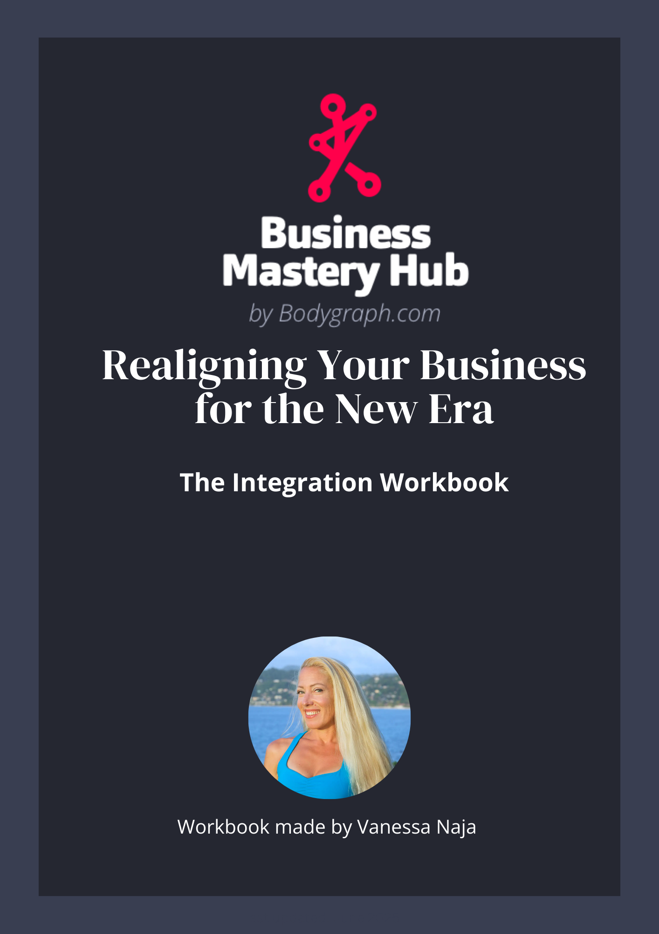

This worksheet is designed to help you integrate what you explored in the workshop and begin applying it to your business and leadership.
Take your time with these questions..

Part 1 - Seeing Your Current Reality
During the workshop we explored the idea that the background frequency of leadership and business is changing.
Many of the strategies that once worked were built inside a different era.
Use the questions below to reflect honestly on your current business.

Where do you feel the shift most strongly?
Which areas of your business currently feel:
- Forced
- Misaligned
- heavy or draining
- unclear
- out of sync with who you are now
Take some time to write or think about it.

Where does your business still reflect pressure or performance?
Examples might include:
- visibility that feels performative
- offers you no longer feel connected to
- messaging that doesn’t sound like you
- trying to replicate someone else's blueprint
- chasing growth rather than aligned contribution
What do you notice?

Where does your business already feel aligned?
Identify where your business currently feels:
- natural
- energizing
- coherent
- connected to your real strengths
These areas often show where your design is already being expressed.
How can you bring more of this into the areas of your business that feel out of alignment?

Part 2 - Authority and Leadership
In Human Design, sustainable decisions come from your inner authority, not from pressure, comparison, or urgency.
Leadership in the new era requires learning to trust and apply your authority in business decisions.
Consider the following.

Where in your business are you currently making decisions from pressure instead of authority?
Consider areas such as:
- pricing
- visibility
- launching or creating offers
- partnerships or collaborations
- saying yes or no to opportunities
- the pace at which you push your business forward
Where do you notice pressure influencing your choices?

Where might your authority need more space in your business decisions?
Authority doesn’t always mean slowing down or waiting. It means allowing decisions to come from the correct place inside you rather than reacting to pressure around you.
Where might you give your authority more space to guide your leadership?

Part 3 - Free Writing Integration
During the workshop you were guided through a writing exercise.
You can repeat this exercise anytime you want deeper clarity.
This exercise helps bypass mental filtering and allows deeper insight to surface.

Instructions
Choose one of the questions below.
Set a timer for 5 or 10 minutes.
Write without stopping.
Do not edit.
Do not organize your thoughts.
Do not try to sound intelligent.
Just keep your pen moving.
If you don’t know what to write, write:
"I don’t know what to write"
until something comes.

Choose ONE question
- Where is my business currently misaligned?
- Where am I still operating from pressure or performance?
- What would realignment require from me as a leader?

Leadership Insight
After writing, read back through what you wrote.
Underline the one sentence that feels the most honest.
Write that sentence here:

This sentence often reveals your next edge of leadership.

Part 4 - Realignment
If you were to begin realigning your business with this new era of leadership, what might shift?

One structure in my business that may need recalibration:

One way my business could more fully reflect who I actually am:

One step I could take in the next 30 days:

Part 5 - Support and Leadership
Realignment often happens faster with support, feedback, and aligned community.

It doesn’t require changing everything at once. It begins with recognizing what needs to change and taking responsibility for making that shift.

Reflect on the following.

One structure in my business that may need recalibration:

This could be an offer, a messaging direction, a business model, a partnership, a visibility strategy, or the way you make decisions.

What structure might no longer reflect who you are becoming?

One decision I could make from authority instead of pressure

What decision might look different if it came from your authority rather than urgency, comparison, or expectation?

One way my business could more fully reflect who I actually am

In the new era, individuality becomes structural. Businesses that reflect the leader behind them become more sustainable and trustworthy.

Where might your business more fully reflect your design, your strengths, and your lived experience?

One step I could take in the next 30 days

Leadership requires action.

What is one concrete step you could take in the next 30 days to begin realigning your business?

Final Reflection
Leadership in this new era is about embodiment, authority, and coherence between who you are and what you build.
Based on what you explored today, what does leadership look like for you going forward?

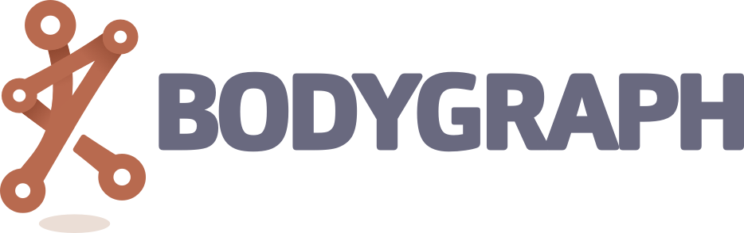

This worksheet designed for Workshop “Human Design & the New Era of Leadership”

Bodygraph.com

