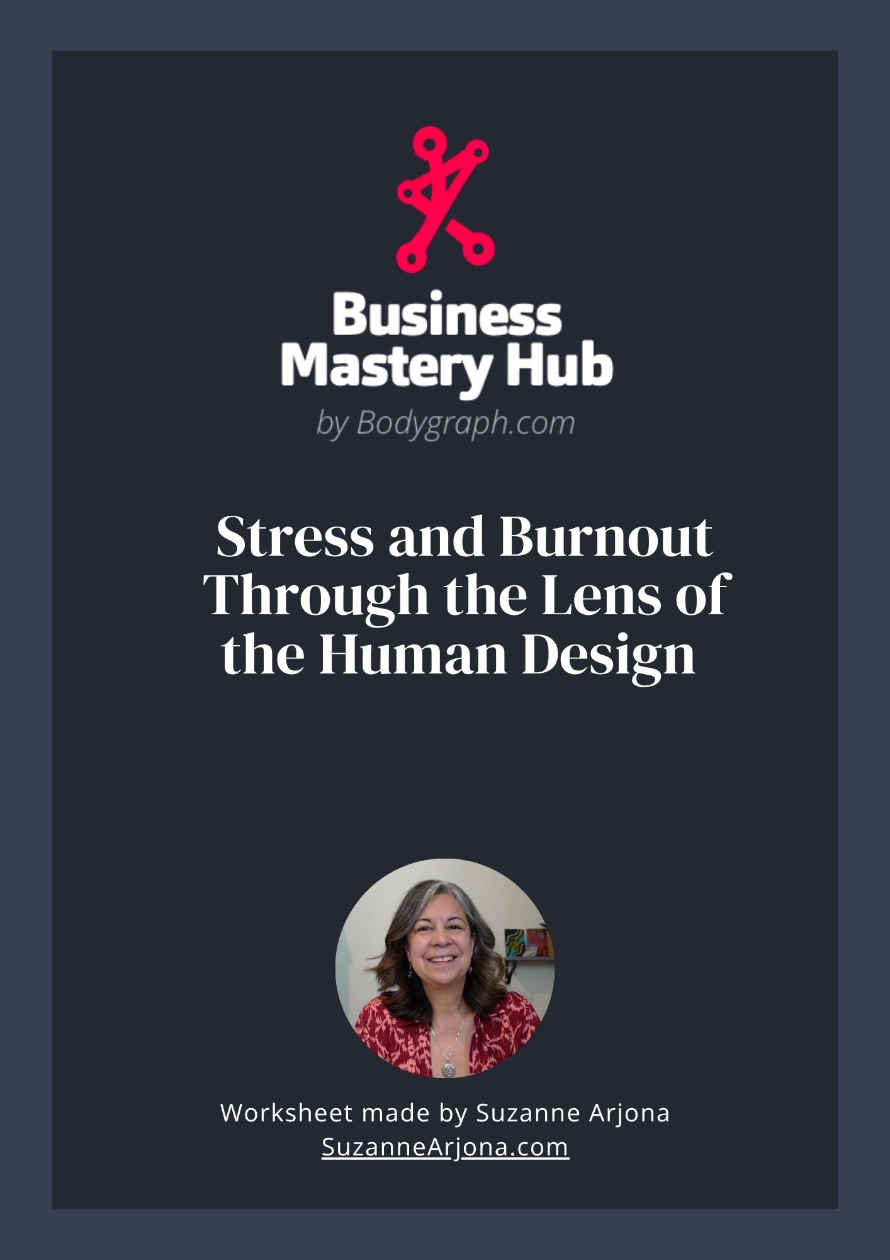The Will Center: Proving Yourself and the Cost of Overcommitment
1. Signs of Stress & Burnout in the Will
- Feeling pressured to prove your value or competence
- Overcommitting to tasks to earn recognition or approval
- Low self-esteem or comparing yourself to others
- Difficulty saying no, leading to exhaustion
- Frustration when results don’t match effort
2. Recognizing Your Patterns
- Notice when actions are driven by proving yourself rather than alignment
- Track situations where you feel depleted from over-committing
- Observe recurring cycles of stress linked to external validation
3. Turning Stress Into Will Center Gifts
Strategy | How It Helps | Quick Tip
Align Action with True Value | Protects energy and reinforces self-worth | Ask: “Does this serve me, or am I trying to prove something?”
Set Boundaries | Prevents overcommitment | Learn to say no without guilt
Recognize Achievements | Supports healthy self-esteem | Celebrate accomplishments, even small ones
Leverage Focused Effort | Turns pressure into productivity | Apply energy to meaningful goals rather than external validation
4. Key Takeaway
- Burnout in the Will Center comes from overexertion to prove value or gain approval.
- When you align action with your true worth, set boundaries, and focus effort, the Will Center becomes a gift: confidence, discipline, and empowered self-expression.
5. Optional Action
- Keep a “Will Alignment Log” for a week: Task/Request, Motivation (Prove vs Align), Energy Outcome
- Review to identify patterns of overcommitment and reinforce aligned effort.
The Throat Center: Expression, Recognition, and the Strain of Being Heard
1. Signs of Stress & Burnout in the Throat
- Feeling unheard, misunderstood, or like your words are ignored
- Pressure to speak or perform before ready
- Difficulty expressing ideas clearly
- Over-talking, over-explaining, or saying “yes” when you want to say “no”
- Fatigue from constant communication or trying to influence outcomes
2. Recognizing Your Patterns
- Notice when you feel compelled to speak even if it doesn’t feel natural
- Track situations where you feel drained after conversations or presentations
- Observe times you over-explain or over-justify yourself
3. Turning Stress Into Throat Center Gifts
Strategy | How It Helps | Quick Tip
Pause Before Speaking | Reduces pressure and miscommunication | Take a breath and check alignment with your truth
Speak From Clarity | Ensures authenticity | Only share what you truly mean or feel compelled to express
Leverage Listening | Builds connection and understanding | Listen first; respond second
Express Creatively | Channels energy productively | Use writing, art, or alternative forms of expression when words feel blocked
4. Key Takeaway
- Burnout in the Throat Center comes from pressure to communicate before ready or authentically.
- When you pause, speak from clarity, and use listening and creative outlets, the Throat Center becomes a gift: authentic self-expression, influence, and connection.
5. Optional Action
- Keep a “Throat Check-In” log: Situation, Pressure Level, Did I Pause/Align?
- Review weekly to notice patterns and reinforce authentic expression.

The Spleen Center: Fear, Survival Mode, and Holding On Too Long
1. Signs of Stress & Burnout in the Spleen
- Chronic worry, anxiety, or indecision
- Physical tension or low-grade health complaints
- Fear-driven choices rather than intuitive ones
- Feeling stuck or overly cautious
- Fatigue from constantly scanning for risks
2. Recognizing Your Patterns
- Notice moments when fear drives your decisions instead of instinct
- Track situations that trigger anxiety or tension
- Observe times you ignore intuitive nudges, leading to stress or missed opportunities
3. Turning Stress Into Spleen Center Gifts
Strategy | How It Helps | Quick Tip
Trust Your Instincts | Reduces fear-based decision-making | Pause and ask: “What does my body/intuitive sense say?”
Release Excess Worry | Conserves energy | Distinguish between real threats and imagined ones
Honor Your Body’s Signals | Supports health and clarity | Notice tension, fatigue, or unease as messages, not obstacles
Use Intuition for Action | Channels fear into timely decisions | Act on small intuitive nudges to build confidence
4. Key Takeaway
- Burnout in the Spleen Center comes from ignoring instincts and overreacting to fear.
- When you trust your intuition, listen to your body, and release unnecessary worry, the Spleen becomes a gift: clarity, discernment, and timely action.
5. Optional Action
- Keep a “Spleen Awareness Log” for a week: Situation, Fear vs Instinct, Action Taken
- Review weekly to notice patterns and strengthen intuitive confidence.
The Sacral Center: Energy, Overwork, and the Risk of Burnout
1. Signs of Stress & Burnout in the Sacral
- Feeling constantly “on” but never fully energized
- Fatigue despite being busy or active
- Overcommitting to tasks or people, leading to exhaustion
- Difficulty saying no or honoring your limits
- Irritability or frustration from doing work that doesn’t feel aligned
2. Recognizing Your Patterns
- Track your energy over a week: note when you feel energized vs. drained
- Notice when you say yes out of obligation instead of excitement
- Observe which activities spark joy and which leave you depleted
3. Turning Stress Into Sacral Gifts
Strategy | How It Helps | Quick Tip
Follow Your Gut Response | Aligns energy with what excites you | Notice your “uh-huh” (yes) or “uh-uh” (no) before committing
Honor Limits | Prevents overwork and burnout | Schedule rest and recovery proactively
Work in Bursts | Matches the Sacral’s natural rhythm | Focus on tasks in energized sprints rather than marathons
Choose Joyful Work | Fuels creativity, productivity, and vitality | Ask: “Does this energize me or drain me?” before taking on a task
4. Key Takeaway
- Burnout in the Sacral Center comes from misaligned effort and overcommitment.
- When you follow your gut, honor limits, and prioritize energizing work, the Sacral becomes a gift: sustainable energy, creativity, and vitality.
5. Optional Action
- Keep a “Sacral Energy Log” for a week: Activity, Energy Response (Lit Up / Neutral / Drained), Did I Listen to My Gut?
- Review weekly to identify patterns of alignment and energy leaks.

The Root Center: Living with Constant Pressure and Overwhelm
1. Signs of Stress & Burnout in the Root
- Feeling constantly pressured to act or keep up
- Anxiety, restlessness, or tension under deadlines
- Overworking to meet expectations or prove productivity
- Difficulty relaxing even when tasks are done
- Fatigue from chronic urgency or overwhelm
2. Recognizing Your Patterns
- Notice when external pressures trigger stress versus internal motivation
- Track situations where you feel rushed, reactive, or overextended
- Observe patterns of acting out of fear of falling behind rather than alignment
3. Turning Stress Into Root Center Gifts
Strategy | How It Helps | Quick Tip
Differentiate Pressure from Urgency | Reduces reactive stress | Ask: “Is this truly urgent or just feeling pressured?”
Prioritize Action | Channels energy productively | Focus on the next aligned step rather than everything at once
Build Micro-Breaks | Prevents burnout | Take short pauses to release tension throughout the day
Use Pressure as Motivation | Transforms stress into action | When aligned, pressure can drive focused productivity
4. Key Takeaway
- Burnout in the Root Center comes from chronic pressure and misaligned action.
- When you differentiate real urgency from stress, prioritize steps, and take micro-breaks, the Root Center becomes a gift: grounded motivation, focused action, and resilience.
5. Optional Action
- Keep a “Root Pressure Log” for a week: Situation, Pressure Level, Action Taken
- Review weekly to identify where pressure is productive versus draining, and adjust accordingly.

The Head Center: Inspiration, Questions, and Mental Overload
1. Signs of Stress & Burnout in the Head
- Feeling mentally scattered, overwhelmed, or unable to focus
- Persistent pressure to answer questions or solve problems immediately
- Racing thoughts or insomnia from “ideas spinning”
- Overwhelm from taking on too many conceptual or abstract tasks
- Anxiety about not knowing enough or being unprepared
2. Recognizing Your Patterns
- Track when your mind feels overactive versus inspired
- Notice situations where you take on questions or problems that aren’t yours to solve
- Observe when mental overload leads to fatigue or indecision
3. Turning Stress Into Head Center Gifts
Strategy | How It Helps | Quick Tip
Capture Ideas | Reduces overwhelm | Keep a notepad or digital list for ideas and questions that arise
Allow Space | Prevents mental burnout | Step back before attempting to answer every question or solve every problem
Focus on Relevance | Prioritizes energy | Ask: “Is this question truly mine to solve?”
Use Inspiration Wisely | Channels mental activity into action | Take one small step toward an idea rather than spinning in abstraction
4. Key Takeaway
- Burnout in the Head Center comes from pressure to know, answer, or solve everything.
- When you capture ideas, allow mental space, and prioritize relevance, the Head Center becomes a gift: inspiration, insight, and innovative thinking.
5. Optional Action
- Keep a “Head Dump” log each day: Idea/Question, Urgency (High/Medium/Low), Action Needed?
- Review at the end of the week to free mental space and spot patterns of overload.

The G Center: Searching for Direction and the Pressure to Belong

1. Signs of Stress & Burnout in the G Center
- Feeling lost, directionless, or like you don’t have a “true path”
- Over-identifying with roles, labels, or environments that don’t feel authentic
- Constantly chasing belonging or approval from others
- Stress from trying to “find yourself” in the wrong places
- Burnout from shapeshifting to fit in instead of standing in your truth
2. Recognizing Your Patterns
- Notice when you’re overthinking identity or trying to force direction
- Pay attention to environments: do certain places or people energize you while others drain you?
- Reflect on times you’ve tried to prove you belong — did it leave you exhausted?
3. Turning Stress Into G Center Gifts
Strategy | How It Helps | Quick Tip
Follow Environments | Right places and people guide you naturally | Ask: “Do I feel more like myself here?”
Release the Pressure | You don’t have to force direction or identity | Let your path unfold over time instead of demanding instant clarity
Value Authenticity | Builds trust and resilience | Choose actions that feel true to you, not just acceptable to others
See Identity as Fluid | Frees you from labels and rigidity | Remind yourself: “I can grow into different versions of me.”
4. Key Takeaway
- Stress in the G Center comes from trying to force identity or direction.
- When you trust your environments and allow authenticity to guide you, the G Center becomes a gift: alignment, purpose, and a natural sense of belonging.
5. Optional Action
- Create a simple “Environment Log” for a week: Where was I? Who was I with? Did I feel more or less like myself?
- Review at the end of the week to see which places and people support your authentic self.

The Ajna Center: Mental Pressure, Certainty, and Letting Go of Control
1. Signs of Stress & Burnout in the Ajna
- Overthinking, rumination, or obsessive mental loops
- Pressure to have all the answers immediately
- Mental fatigue or “analysis paralysis”
- Anxiety from trying to control outcomes or predict everything
- Feeling intellectually stretched but not grounded
2. Recognizing Your Patterns
- Notice when your thoughts repeat or spiral without resolution
- Track situations where you feel pressure to “know it all”
- Observe moments when mental exhaustion leads to indecision
3. Turning Stress Into Ajna Gifts
Strategy | How It Helps | Quick Tip
Step Back From Certainty | Reduces mental strain | Pause before deciding; allow ideas to settle
Observe, Don’t Force | Prevents overthinking | Watch thoughts as passing waves rather than commands
Leverage Inquiry | Turns mental energy into insight | Ask “What’s useful here?” instead of “What must I know?”
Ground Ideas in Action | Avoids endless rumination | Pair reflection with small practical steps
4. Key Takeaway
- Burnout in the Ajna arises from mental pressure and the need for certainty.
- When you step back, observe, and channel thoughts into actionable insight, the Ajna becomes a gift: clarity, perspective, and thoughtful decision-making.
5. Optional Action
- Create a brief “Thought Tracker” for a week: Thought/Idea, Emotional Pressure Level, Actionable Next Step?
- Review at the end of the week to identify recurring loops and gain clarity.



About Suzanne

Hi, I’m Suzanne Arjona, Life Management Guide and Human Design Specialist. I help women reconnect with who they are at their core and navigate life’s turning points - career shifts, relationship changes, and the many stages of life - with confidence and ease, so they can reduce stress and truly live life on their terms.
You can find me at SuzanneArjona.com, my weekly blog The Alchemy of You on Substack, and on my podcast Life on Your Terms, where I share insights on Human Design and personal transformation.

Website: https://suzannearjona.com
Blog/Podcast: https://suzannearjona.substack.com
Email: Suzanne@SuzanneArjona.com

Instagram: https://www.instagram.com/suzanne.arjona/

Ready to Bring Your Human Design Insights to Life?

Take what you’ve learned in this worksheet and put it into action with Bodygraph.com the leading Human Design and Astrology software for practitioners.
Create unlimited charts, generate detailed reports, and access the tools you need to grow your business - all in one place.
Bodygraph.com

