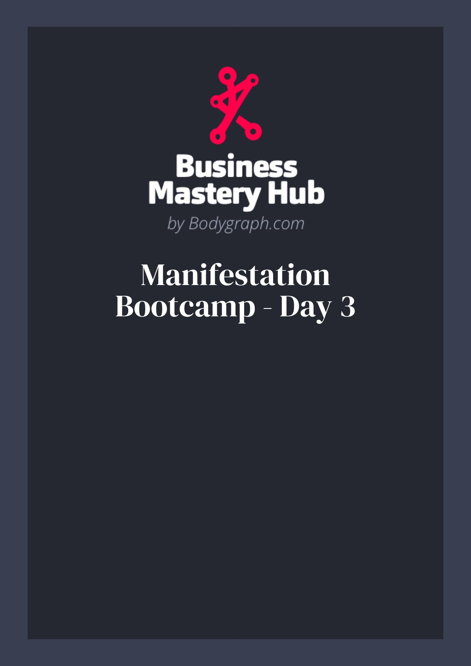
Day 3 - Q&A Integration Toolkit
Use this toolkit to integrate insights from the Day 3 Q&A: clarify your concept of self, practice receiving, communicate in alignment with your Type, and turn lived experience into offers you can sell.

Core Concepts (Quick Ref)
- Passenger / Vehicle / Driver: Personality Crystal observes, Design Crystal is the body-tech, the Magnetic Monopole (Gate 2) is the driver holding your direction.
- Limousine metaphor: Who’s riding with you? Untrue concepts of self create noise for both the driver and passenger.
- Torus field & manifestation: Your thoughts–feelings–actions set the frequency that circulates and returns as matches.
- Transmutation: Experiences enter through openness; alchemize them into wisdom, frameworks, and offers.
- Embodiment > information: Make decisions from the center (Monopole), not the outer merry‑go‑round.

Exercise 1 — Limousine Roll‑Call
Goal: Identify and release false concepts of self that interfere with your direction and receiving.
- List the top 5 recurring inner voices (e.g., people‑pleasing, unworthy, too young/too old).
- Next to each, write whose voice it originally was and what it tried to protect you from.
- Decision: Keep or release. If release, write a one‑line eviction: “Thanks for your service; you’re no longer driving.”
- Replace with a truth statement that centers your Monopole (e.g., “I deserve aligned love/clients/money.”).

Exercise 2 — Receiving Reset (Gate 2)
Goal: Rebuild your capacity to receive support, love, clients, and money.
- Audit (today): Where did I deflect help, compliments, or payments? What belief was underneath?
- Micro‑practice (daily): Say “thank you, I’ll receive that” once for support, once for praise, once for money.
- Somatic cue (90 seconds): When triggered, breathe slowly and let the wave pass before making meaning.

Exercise 3 — Imagination to Form
Use imagination as a 4D/5D drafting room before action in 3D.
- Future snapshot: Close eyes; experience a vivid 2‑minute scene of your desired outcome (clients, partner, launch).
- Decode: What actions would the “future‑you” take this week? List 3 and schedule them.
- Embodiment check: “Would a $X coach / aligned partner version of me do this?” Adjust choices accordingly.

Exercise 4 — Communication Scripts by Type
Customize these to your tone. Use them verbatim to start, then edit.

Generators & MGs
- Prompt response: “I’m noticing energy when I talk about ____. Do you want X or Y from me right now?”
- Boundaries: “That’s not a yes in my body; let’s revisit on ____.”

Projectors
- Inform + Ask: “I’m noticing ____ (observation). Would you like a more satisfying way to approach it?”
- Invitation hygiene: “Here’s how I work and where I’m most effective. Is that what you want?”

Manifestors
- Initiate + Inform: “I’m starting a container on ____. If it’s a yes, here’s how to plug in; otherwise no worries.”
- Rejection reframe: Track no’s as progress (clears space for correct yes).

Reflectors
- Lunar dial: Pre‑plan key decisions for windows when your transits bridge core gates/centers.
- Environment check: “In this place/with these people, does my body soften and clarity grow?”

Exercise 5 — Rejection Celebration Log
Goal: Desensitize to “no” and increase aligned opportunities.
# | Outreach (who/where) | Result | Follow‑up by | Lesson
1
2
3
4
5
6

Exercise 6 — Triple‑Split / Split Care
- Give it time: Let ideas incubate across your splits; clarity grows with space.
- Bridges: People/places that connect your splits can ease expression—use them consciously (mentors, groups).
- One‑topic lanes: Communicate one lane at a time; stop trying to bridge all splits in one post/convo.

Exercise 7 — Duties & Roles Clarity (for collaborators)
Get specific so the right people can recognize themselves and say a clean yes/no.
Duty/Outcome | Hours/Wk | Type fit (G/MG/P/R) | Notes/SOP link

Exercise 8 — Cognition Cues (Inner Vision / Smell)
- Inner Vision: Make decisions with eyes gently closed. Note recurring images, colors, or “clear vs. cloudy” scenes that mark a yes/no. Create your personal legend (e.g., pink = yes, grey = no).
- Smell: Notice “clean vs. off” scents/air qualities around people, places, offers. Track patterns for a month.

Exercise 9 — Transmutation Grid (Turn Experience into Offer)
Raw experience | Lesson/Wisdom | Framework name | Who needs it | Offer format

Exercise 10 — 2027 Readiness (Embodiment)
- Nervous system care: Choose 2 daily practices that bring clarity (walks, breath, sleep boundaries).
- Authority practice: Write 3 decisions you’ll make only from your centered space this week.
- Integrity audit: Where are you outsourcing authority (health, biz, love)? Bring one choice back home.

Daily Checklist
- Evict one false concept from the limousine.
- Receive one thing fully (support/praise/money).
- Take one future‑you action.
- Make one aligned outreach and log it (celebrate the result—yes or no).

