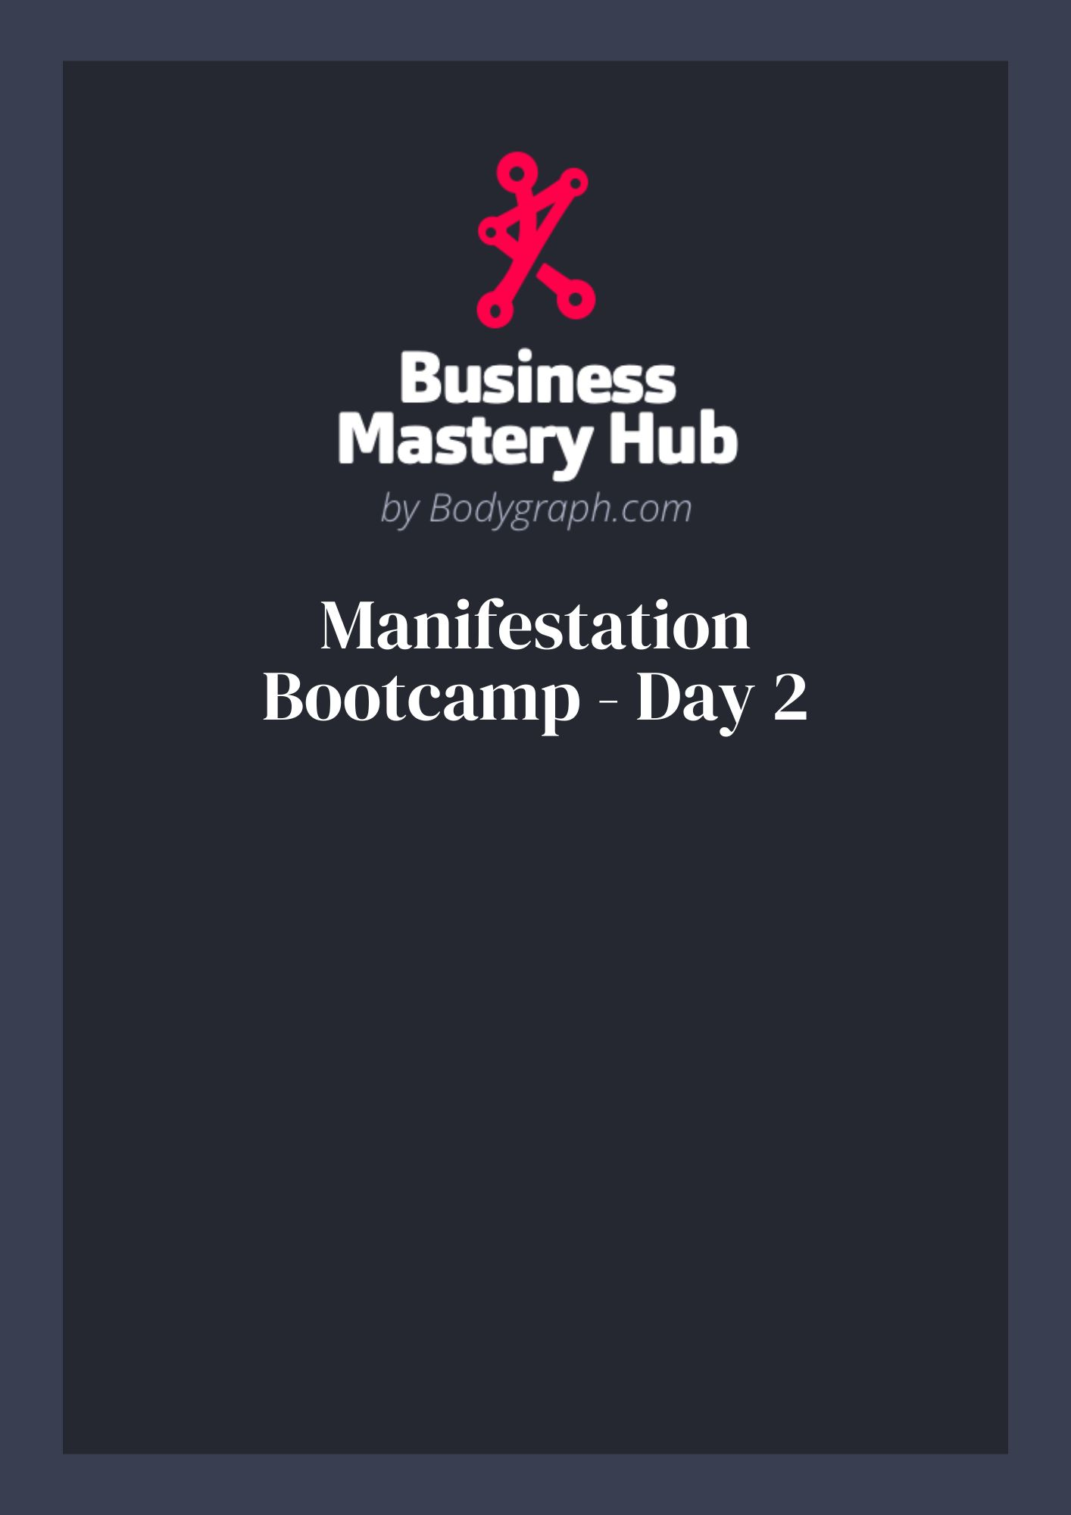

Overview
Use this worksheet to turn ‘open center’ experiences into usable wisdom, reframe conditioning, and outline simple actions that align with your design. Bring Day 1’s self‑concept insights with you.

Objectives
☐ Spot where conditioning enters (open centers) and where it tends to live (defined centers).
☐ Practice the 90‑second nervous‑system reset when triggered.
☐ Reframe a story (cognitive reappraisal) and write the new self‑concept line.
☐ Map one offer or message that leverages your openness as Profit Potential.

To‑Do Activities
☐ Open Center Scan — List each open/undefined center and one recent situation that flowed in through it.
☐ Defined Center Check — Note where that story ended up ‘living’ in you (which defined center/pattern).
☐ 90‑Second Practice — When a trigger appears today, set a timer for 90 seconds and only feel it pass.
☐ Reframe — Write a clean, empowering reframe for one sticky story.
☐ Offer Draft — Translate one reframe into an offer, post, or client prompt you could sell or share.

Open Center Mapping
Center | Recent Situation | Old Story / Feeling | New Reframe

Reframe Lines
Old line I’ve believed: ________________________________________________
New line I choose (first-person, present tense): ___________________________
Behavior I’ll try next time: _____________________________________________

90‑Second Trigger Log
Date/Time | Trigger | Sensations felt (90s) | What I learned

Offer or Message Sketch (Turn Openness into Value)
Audience I help: _________________________________________________
Problem they feel (their words): _________________________________
My insight from openness: ________________________________________
Simple promise: _________________________________________________
Call‑to‑action I’ll use: __________________________________________

Homework
☐ Pick ONE open‑center insight and ship something: a post, story, email, or 1:1 outreach.
☐ Practice the 90‑second rule at least once. Write what shifted afterwards.
☐ Update your Day 1 self‑concept with today’s reframe.

Reflection Prompts
• Where did I notice resistance today? What layer of conditioning was beneath it?
• What felt easier after I reframed it?
• How did my body feel before vs. after the 90‑second pause?

Notes
_______________________________________________________________
_______________________________________________________________
_______________________________________________________________
_______________________________________________________________
_______________________________________________________________
_______________________________________________________________
_______________________________________________________________
_______________________________________________________________

