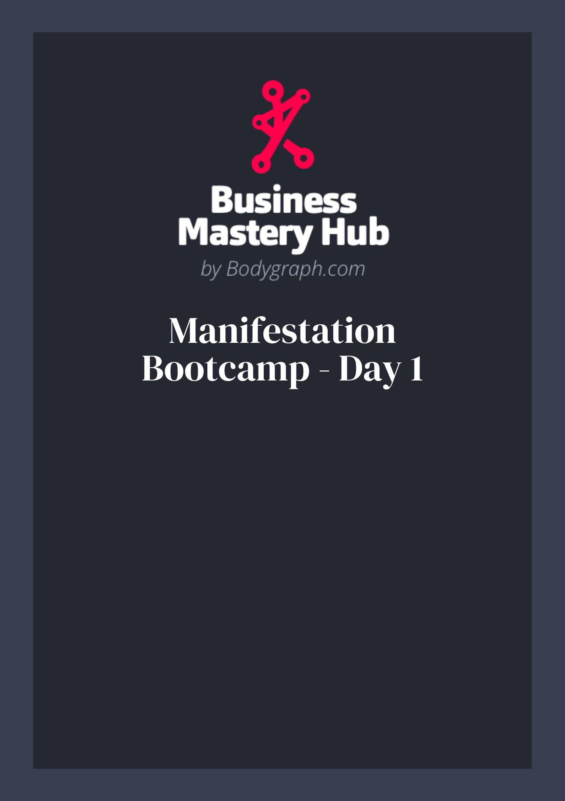

Concept of Self + Field of Potential
Use this workbook to translate today’s ideas into action. You’ll map your current self‑concept, clear conditioning, and practice cognition‑led imagination so decisions come from your future state, not your past.

1) Day 1 at a glance (quick primer)
- Everything is frequency. Your language + beliefs set the tone of your magnetic monopole (G Center), which attracts experiences.
- Manifestation begins with a decision. Decide as if it’s already done, then act via Strategy & Authority.
- Field of Potential reflects (like a Reflector) and responds (like an Emotional MG) to your self‑concept.
- Passenger / Driver / Vehicle. Keep the backseat “party people” (old conditioning) from grabbing the wheel.
- Focus beats frenzy. Contract desire to one lived scene/sensation (41) and surrender timing to the fates (30).

2) Vocabulary cheat‑sheet
- Self‑Concept: The story you hold about who you are & what’s possible.
- Conditioning: Adopted opinions/beliefs lodged in your subconscious; often speaks in limiting “truths.”
- Magnetic Monopole (Gate 2): The inner GPS that holds you together and attracts experience by frequency.
- Cognition (Tone): Your primary sense for knowing (Taste, Smell, Inner Vision, Outer Vision, Feeling, Touch).

3) Pre‑work self‑scan (circle one per line)
Energy toward goal today: flat — 1 2 3 4 5 6 7 8 9 10 — alive
Self‑talk tone: harsh — 1 2 3 4 5 6 7 8 9 10 — supportive
Decision source lately: outer pressure — 1 2 3 4 5 6 7 8 9 10 — Strategy/Authority
Focus: scattered (many goals) — 1 2 3 4 5 6 7 8 9 10 — one clear scene

4) Concept‑of‑Self audit
Prompt A – Current story
Write three sentences you actually think/say about this goal (money, clients, relationship, health, etc.): - 1) - 2) - 3)
Prompt B – Source check (Where did each come from? Parent, teacher, boss, culture, past you?) - 1) - 2) - 3)
Prompt C – Evidence breaker (List one counter‑fact for each): - 1) - 2) - 3)
Prompt D – Chosen identity (Future‑you who already lives it): - I am the person who… - My work/relationships feel… - People experience me as…

5) Deconditioning map (belief → new directive)
Use this mini‑pipeline to rewrite one stubborn belief. - Old belief: - How it protects me / payoff: - Cost if I keep it: - New directive (clear, kind, present‑tense): - Proof I can gather this week:
Tip: Keep your language non‑harmful (Gate 26) and self‑leading (Gate 10). Speak to yourself like an ally.

6) Cognition‑led imagination lab (choose your Tone)
Pick the box that matches your cognition and immerse in a single future scene. Keep eyes open for Outer Vision; eyes closed or soft focus for others. Live it for 2–3 minutes.
- Taste: What does success taste like here? First sip/first bite? Describe textures/flavors.
- Smell: What scents confirm it’s real (room, air, paper, gear, flowers, ocean, backstage)?
- Inner Vision: See the scene inside your mind. Colors, light, the exact moment you know “it’s done.”
- Outer Vision: Keep eyes open. Arrange a beautiful setting; let the room show you it’s real.
- Feeling: Where in your body do you feel it? Temperature, weight, pulse, goosebumps.
- Touch: What are your hands on? Keyboard, mic, steering wheel, door handle, fabric. Texture details.
Anchor sentence (say aloud):
“Because I am [identity], I’m experiencing [one vivid sensation].”

7) Future‑Self decision drill (act from ‘already done’)
Pick one domain: ☐ Business ☐ Relationships ☐ Wellbeing ☐ Money
Future state (one line):
Today’s decision, made as that person:
- Who am I being as I decide?
- What exact action do I take in the next 24 hours?
- Why (value/principle behind it)?
Strategy & Authority checkpoint:
Describe how you’ll run this decision through your S&A before acting:

8) Monopole alignment – Language & frequency tuner
Scan your speech for 60 seconds. Jot 3 phrases you catch: 1) 2) 3)
Upgrade them into frequency‑clean statements:
(“I am…”, “Clients love…”, “Money is…”) 1) 2) 3)
Activation statement (read morning/night):
“I am [identity]. I move like [value]. I decide from [Strategy/Authority]. It is done.”

9) Focus + Surrender (41 → 30)
- Contract to ONE scene (no more than 3 sentences):
- Release ritual (choose one): ☐ breathe 10 cycles ☐ write + fold paper ☐ hand‑on‑heart ☐ short walk.
- Timing note: Emotion introduces intervals. We don’t control when or how. We steward who/what/why.

10) Daily practice tracker (7 days)
Day | 3‑min imagination | One ‘done‑state’ decision | Language check | Strategy & Authority honored?
1 | ☐ | ☐ | ☐ | ☐
2 | ☐ | ☐ | ☐ | ☐
3 | ☐ | ☐ | ☐ | ☐
4 | ☐ | ☐ | ☐ | ☐
5 | ☐ | ☐ | ☐ | ☐
6 | ☐ | ☐ | ☐ | ☐
7 | ☐ | ☐ | ☐ | ☐

11) Open G / Undefined G notes (optional)
- Use your G Center like a beacon: “Right place, right people?” Let cognition + body say yes/no as you approach.
- Let environment and people inform your direction; don’t force an identity costume.

12) Tribe vs. Self (boundary check)

List the tribal norms that might push conformity over differentiation (family, workplace, industry):
- My boundary this week:

13) Micro‑wins log (evidence builder)
- Today I noticed a lighter word/choice:
- Someone responded to my new frequency by:
- Proof I’m already becoming this person:

14) Parking lot (ideas for later)

Bring to Day 2: Transmutation of Energy
- Your one contracted scene
- 1–2 rewritten beliefs
- A decision you ran through Strategy & Authority
Remember: Who you’re being + what you do + why you do it are your job. How/when is not.

